Conditions in bash scripting
- If count is equal or not equal
Vi if-script.bash
#!/bin/bash
Count=100
If [ $count =eq 100 ]
Then
Echo count is 100
Else
Echo count is not 100
fi
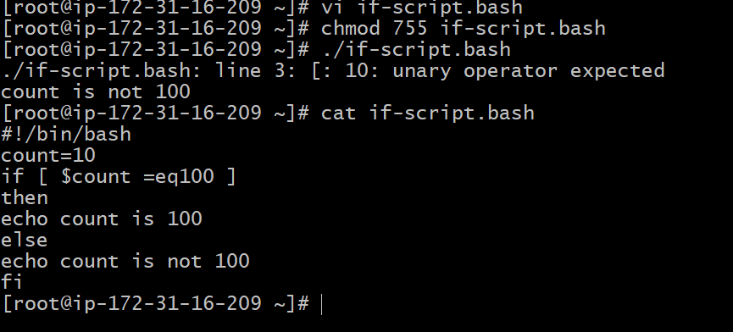
- Create a bash script to check if a directory is available or not.
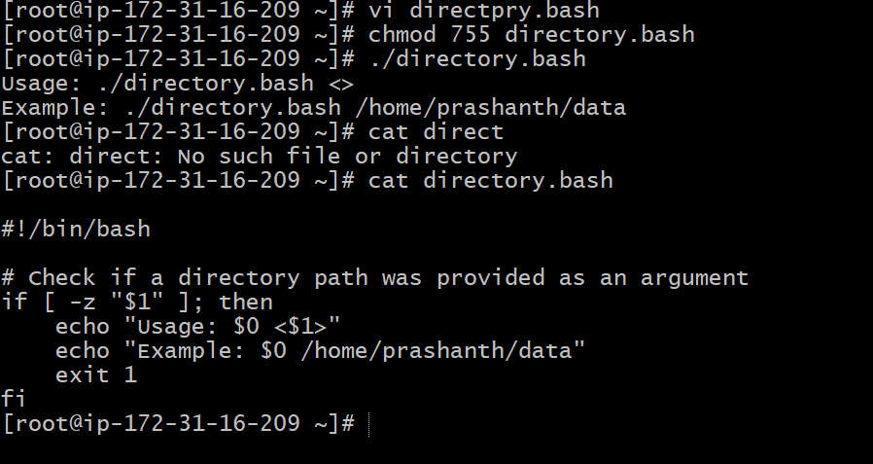
- Create a bash script to create multiple files
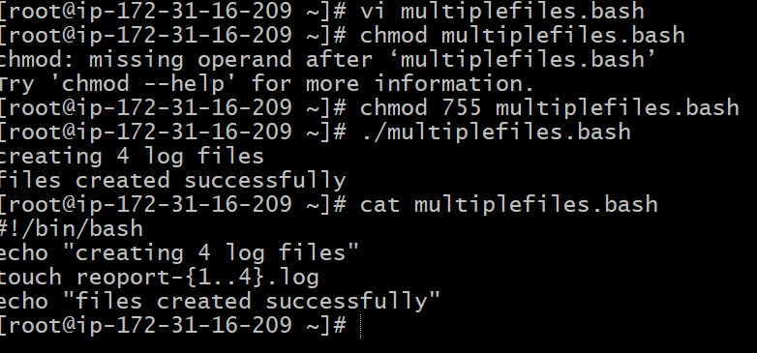

- Create a bash script to install Nginx on an EC2 server.
#!/bin/bash
Sudo yum install nginx -y
Sudo systemctl start nginx
Sudo systemctl status nginx
After executing
Chmod 755 nginx.bash
./nginx.bash

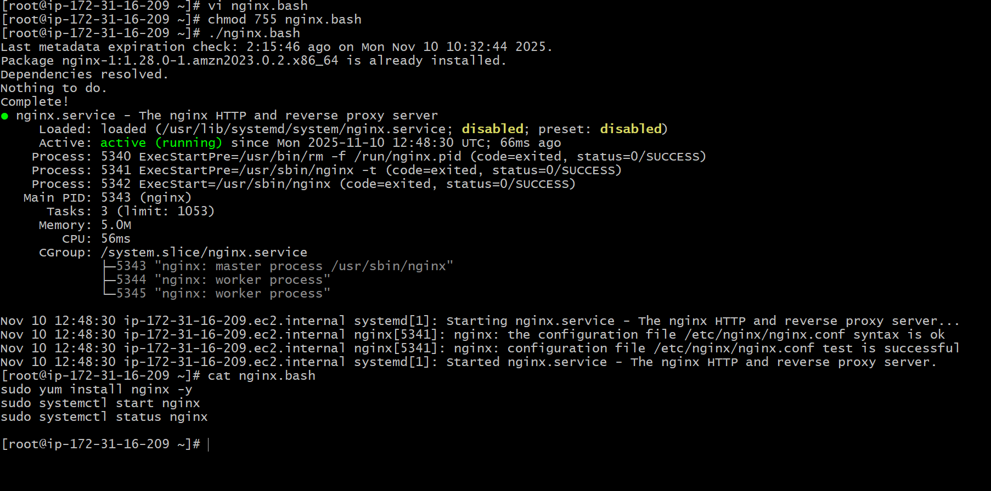
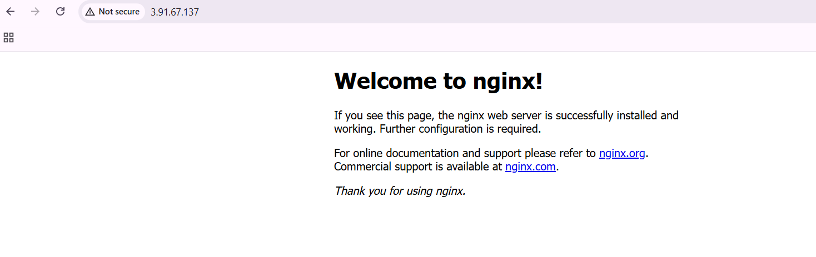
- Create a bash script to check if Nginx Service is running, if not running then script should start the service.

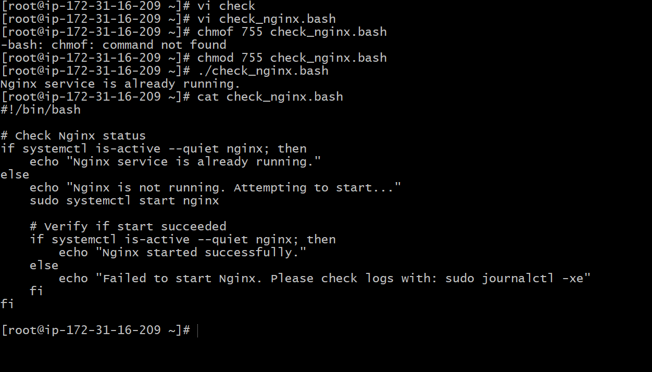

- Create a bash script for a calculator
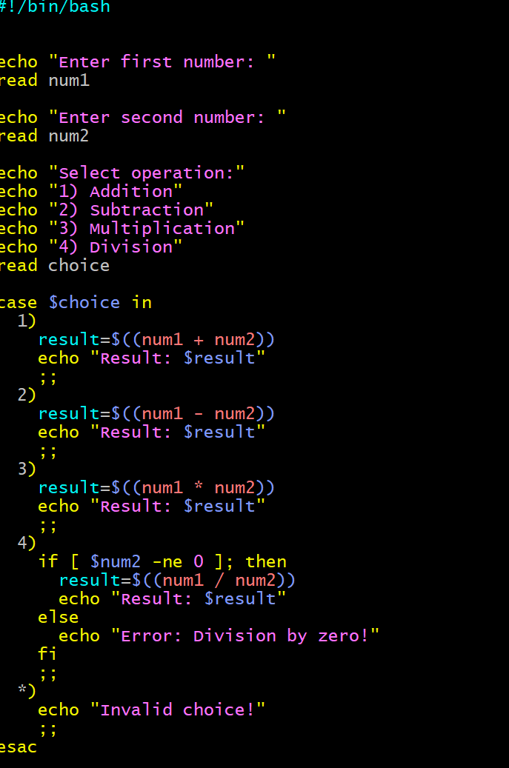
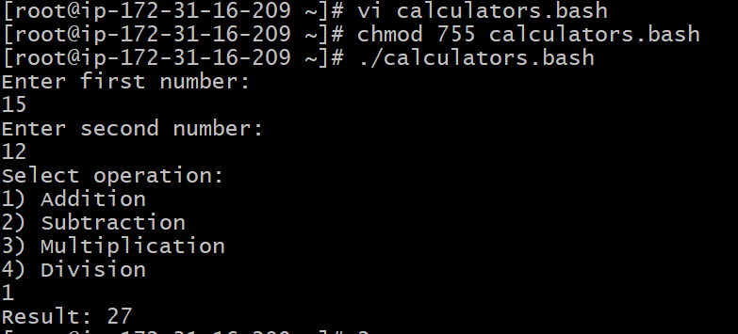
- Create a bash script to check if a directory exists, if not then create a directory.
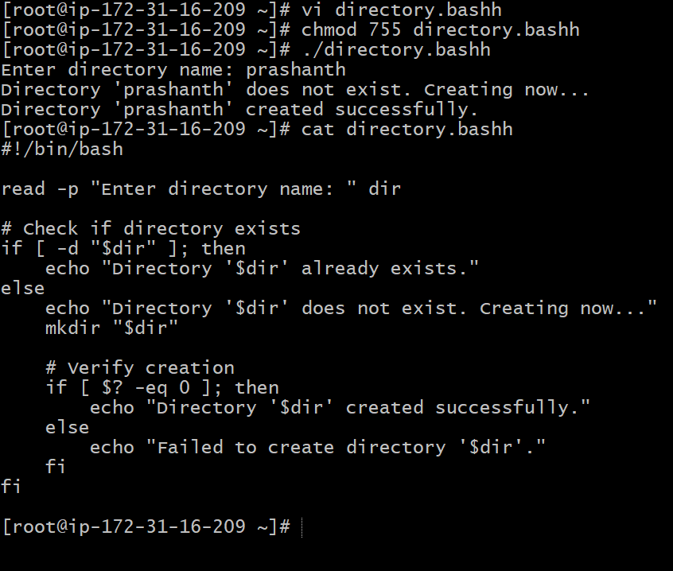
- Create a bash script to delete the last 3 lines of a file.
we need to add numbers 1 to 10 in filename.txt
after fiving permissions enter file name and give cat filename

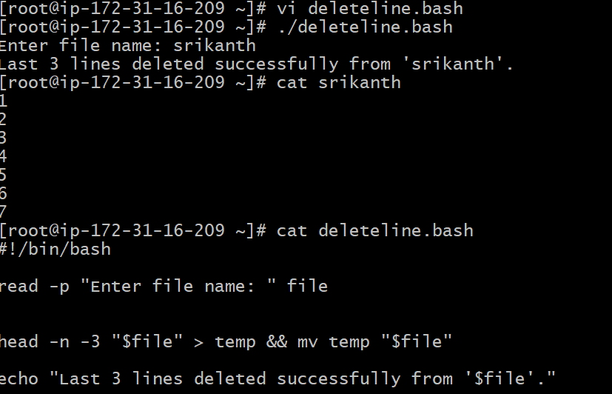
- Bash script to monitor cpu and if it is more than 80% then send email notification.
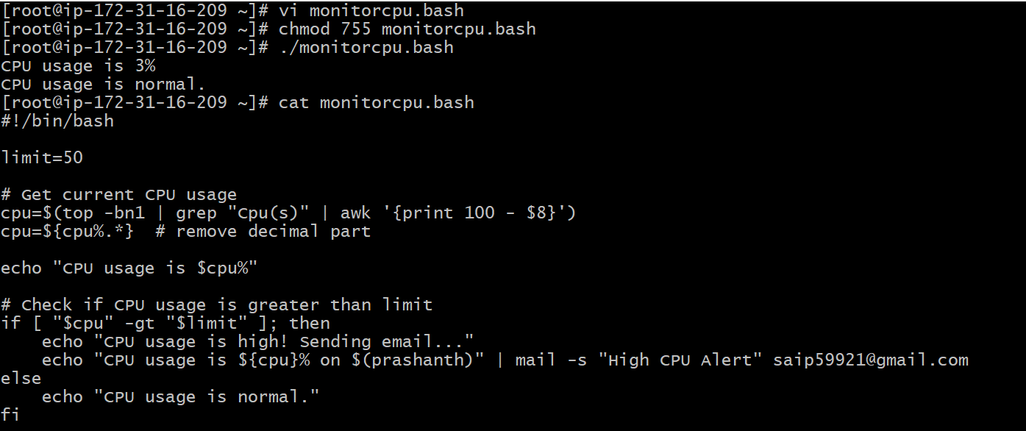
- Bash script to monitor disk space and if it is more than 80% then send email notification.
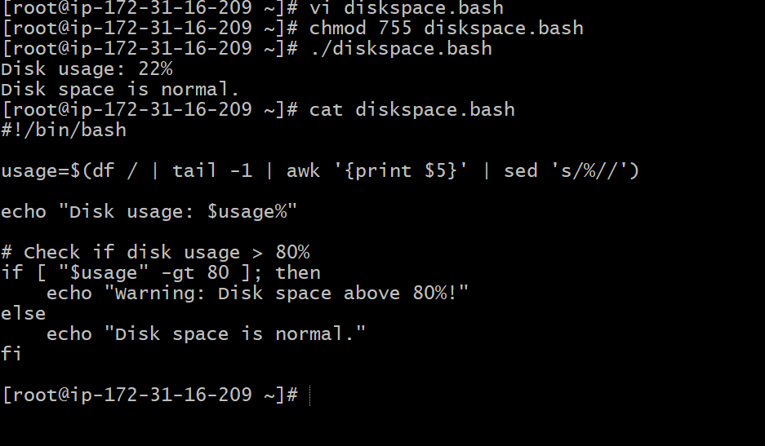
- Bash script to monitor memory and if it is more than 80% then send email notification.
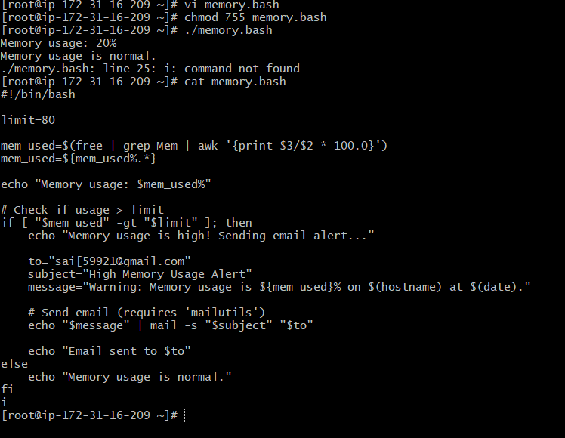
3 Create a bash script to take a backup of a directory.
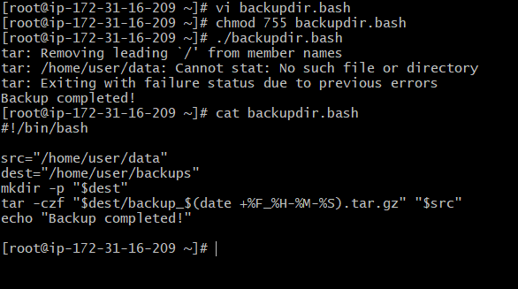
5 Create a bash script to install Apache Tomcat on an EC2 server.
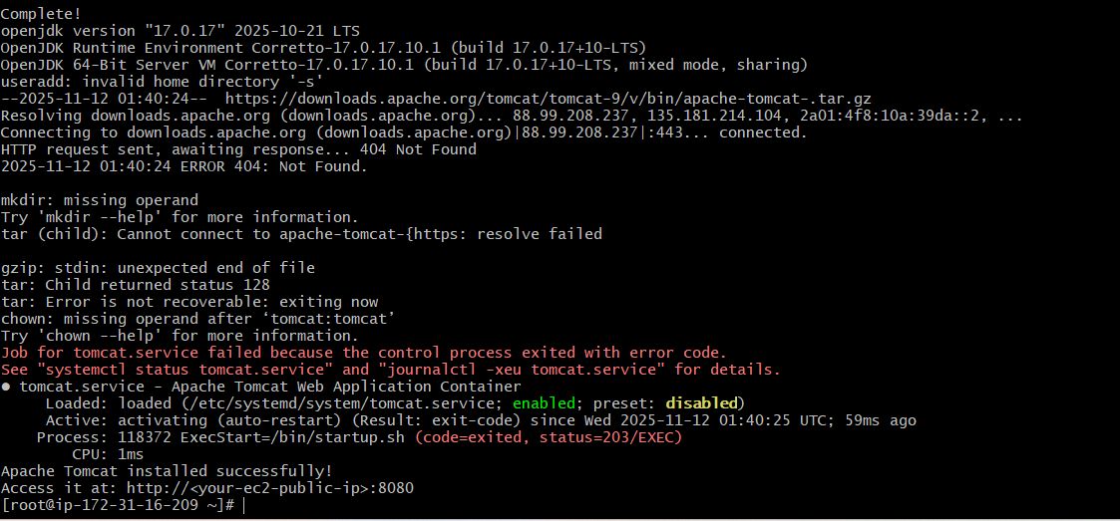
Crontab entries
1 april 5th midnight
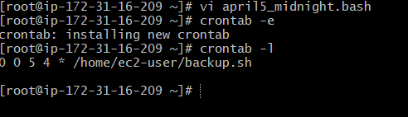
2 5th of Every November, January, June if it is a Thursday

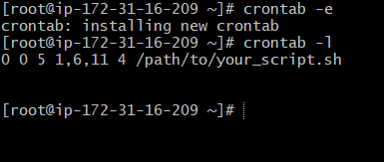
3 At 05 and 27th minutes of 9, 10, 11 hours every day
Minutes → 5,27
Hours → 9,10,11
Day → * (every day)
Month → * (every month)
Weekday → * (any day)
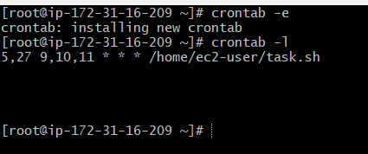
- 34 minutes of 9th hour on 15th August
34- minute
9th hour- 9 am
15- day
8- month of august
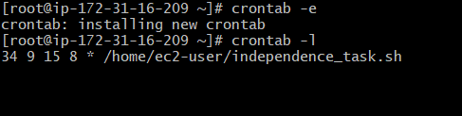
- Every midnight
- – minute
0 – Hour
*-everyday,everymonth,everyday of the week
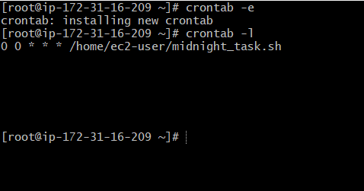
- Every Weekend (Saturday night 11:59 PM)
- – minute, 23 -11pm, *everyday,everymonth, 6 - saturday
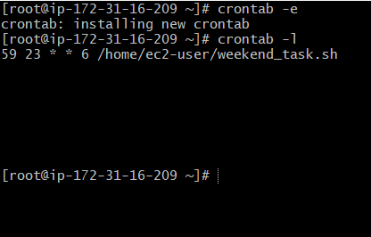
- After every reboot
every time the EC2 instance (or system) reboots.
